

AI Assisted Problem Solving Using Python

AcademicYear:2025-2026

Assignment Type: Lab
Assig_No. 6

Submitted by:
Name: NUKALA MEGHANA SRI
Enroll No.2503b05113
Course: M-Tech CSE

Submitted to:
Name: Venkataramana Veeramsetty
Title: Course Instructor

Date: 04 Nov 2025

Expected Output#1
- Class with constructor and display_details() method
Prompt:
- Generate a Python class named Student with attributes name, age, and course. Include a method display_details() that prints the student information.
Generated Code:
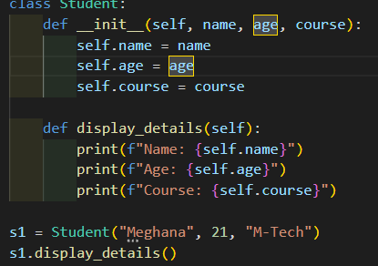
Explanation:
- AI-generated a well-structured class with a constructor __init__() and an instance method display_details().
- The code is syntactically correct, logically clear, and demonstrates good use of object-oriented programming concepts.

Example Output:
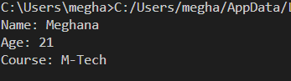

Task Description#2 (Loops)
- Prompt AI to complete a function that prints the first 10 multiples of a number using a loop.
- Analyze the generated code
- Ask AI to generate code using other controlled looping
Expected Output#2
- Correct loop-based implementation
Prompt:
Write a Python function that prints the first 10 multiples of a given number using a for loop.

Generated Code:
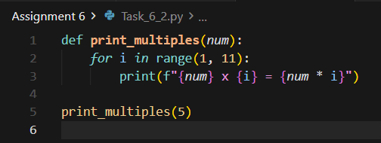
Explanation:
- The code uses a for loop and the range() function to iterate through values from 1 to 10, multiplying each by the input number.
- It provides a simple, clear, and complete loop-based solution for printing multiplication tables.
Example Output:

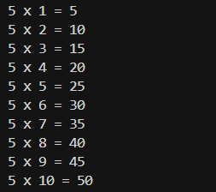
Task Description#3 (Conditional Statements)
- Ask AI to write nested if-elif-else conditionals to classify age groups.
- Analyze the generated code
- Ask AI to generate code using other conditional statements
Expected Output#3
- Age classification function with appropriate conditions and with explanation
Prompt:
Write a Python function that classifies a person based on their age:
- Below 13 → “Child”
- 13–19 → “Teenager”
- 20–59 → “Adult”
- 60+ → “Senior”

Generated Code:
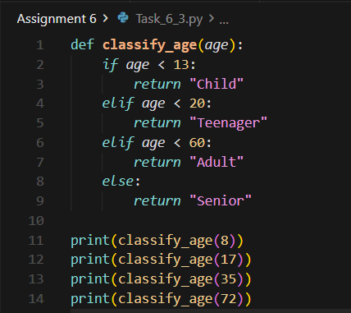
Explanation:
- AI implemented nested conditional statements accurately using if-elif-else.
- The code is clear, correctly categorizes age groups, and provides concise outputs for different ranges.
Example Output:

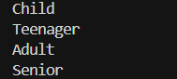

Task Description#4 (For and While loops)
- Generate a sum_to_n() function to calculate sum of first n numbers
- Analyze the generated code
- Get suggestions from AI with other controlled looping

Expected Output#4
- Python code with explanation
Prompt:
- Write a Python function sum_to_n() that calculates the sum of the first n natural numbers using both for and while loops.
Generated Code (for loop):
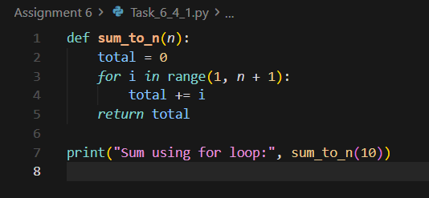
Generated Code (while loop):

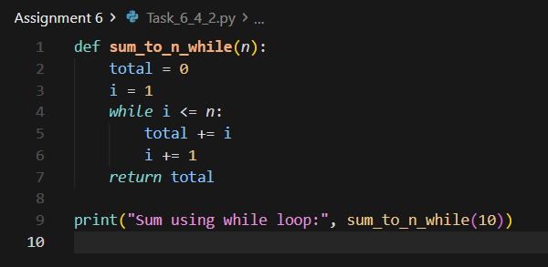

Explanation:
- AI suggested both for and while loop approaches.
- Both methods iterate through the range of numbers and accumulate the total.
- This demonstrates how AI can generate multiple valid control structures for the same logic.
Example Output:

Task Description#5 (Class)
- Use AI to build a BankAccount class with deposit, withdraw, and balance methods.
- Analyze the generated code
- Add comments and explain code

Expected Output#5
- Python code with explanation

Prompt:
- Create a BankAccount class with methods to deposit, withdraw, and check balance.
Generated Code:

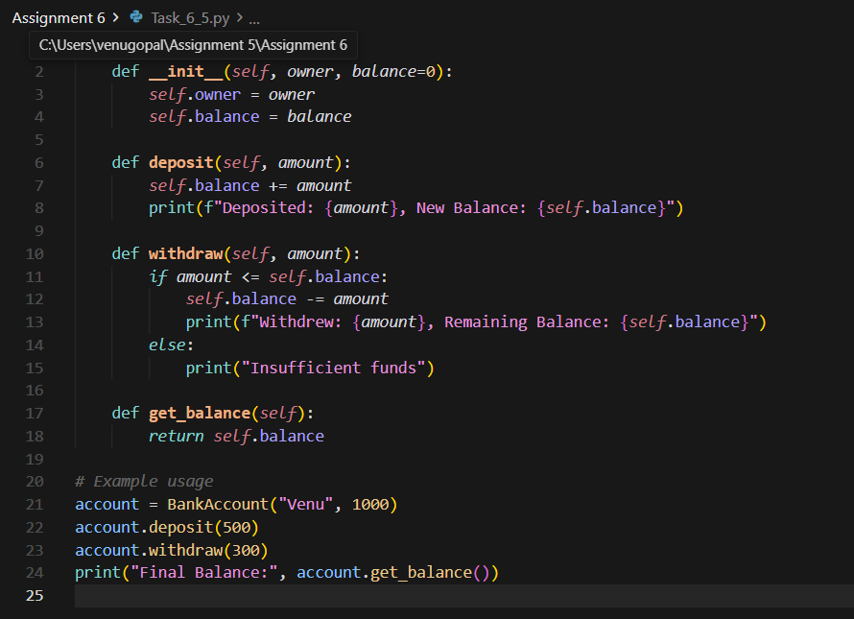
Explanation:
- AI successfully generated a class-based solution modeling a simple bank account system.
- It correctly implemented encapsulation and balance validation logic.
- Each method performs its function cleanly and gives user-friendly output messages.
Example Output:

